**ASSIGNMENT 8.3**

**Write a Pig UDF To find the tweets posted by @realDonaldTrump from the given dataset.**

UDF CODE :

Udf code is commonly used to perform the filtering operation for the realDonaldTrump tweets. Thus works as a filtering application.

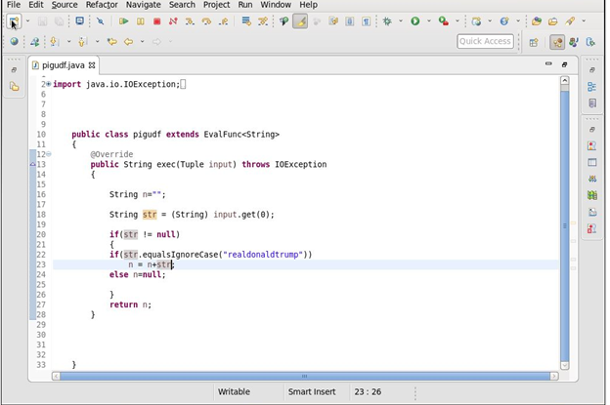

Later by the application of the pig scripts(in pig latin form) the filtering operation is done to filter the required null values and count the tweets needed.

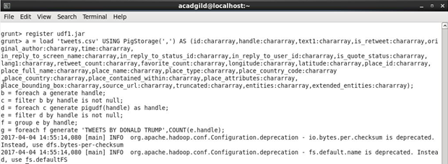

This is the final step that represents the required tweets.

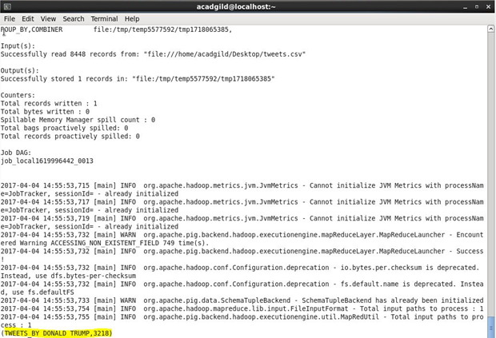

Thus the tweets that are done by Donald Trump is obtained as shown below respectively.

